**Development Project:** [CompareJobOffers.net](http://comparejoboffers.net/)

The key to this WebApp is the user can have two scenarios; One compare multiple jobs offers, and secondly enter a fulltime time job offer to what it equates to hourly wages

Software development life cycle:

|  |  |  |  |
| --- | --- | --- | --- |
| Discipline | Tools | Deliverables | Owner/  Participate |
| Project planning/ Requirements | Jira - MS Word/Excel | Project plan requirements | Tyrone |
| Infrastructure/Cloud | AWS | Ec2 instances | Tyrone |
| Developing – code, unit test | Github, IDE, PHP, Node.js | CJO Web App | Tyrone/Travis |
| SCM/Build/Deploy | Github, Jenkins |  | Tyrone/Travis |
| QA and testing | Manual test | Tested application | Teddy/Peggy |
| Stage/Production support | Jenkins, AWS | Deployed Env. | Tyrone/Travis |

**Requirements -** (Technical Jobs)

The key to this App is the user can have two scenarios; One compare multiple jobs offers, and secondly enter a fulltime time job offer to what it equates to hourly wages.

1. Create home page that introduces the CJO App and how it works
2. Add a “Getting Started” button to the home page
3. Create form to allow user enter profile info - including login
   1. Full Name
   2. Email address (will be used as username)
   3. City and State
   4. Education level – (HS, AA, BS, or PhD)
   5. Experience (no of years)
   6. Skills - /w number of years
   7. Rank training base of importance
4. Create a form the gather info about an offer – allow user to enter multiple offers
   1. Name of companies with offer
   2. Type of business
   3. Size (Fortune 100-500)
   4. State (select option)
   5. City (select base on state)
   6. Type of Offer - Fulltime/Contract (radio button)
   7. Pay base on – f (Annually/Hourly)
   8. Relocating – City/State
5. Create a report that priorities the offer base on
6. Create MySQL Database and tables - CJO-Model
   1. User
   2. Offers
   3. Job
   4. Education
   5. Skill Profile
   6. Lookup tables: - see CJO-Diagram 1.0 (below0
      1. City/State cost of living (City1 to City2)
      2. Companies – if possible
      3. Skills
      4. Job type and area
      5. Pay base on job type
      6. Weighted value you table
      7. Tax table – state with no income
      8. Sector / Positions /Major

**+**

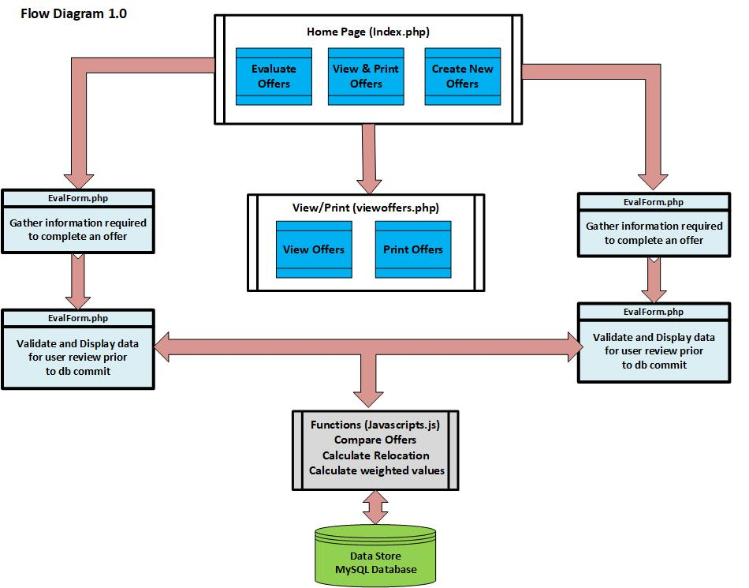

**Converting Full Time Pay to Hourly Contract Rate – (JavaScript.js functions)**

Multiple people asked me this week how much they should charge for an hourly development engagement, trying to figure out what’s fair. They all know their full time salary range but didn’t know how to translate that into self-employed hourly rate. This post is a quick explanation of the formulas I use. This is obviously not an industry standard or what your next employer (or employee) is going to use but you might find it a useful reference point. This is limited to US based employment.

Needless to say, these formulas ignore the many employer tax differences of employing W-2 vs 1099 employees. They are also ignoring the most important factor which is the human element. We are talking about people hiring other people where unique skill sets, personalities, and economic realities can often mean more.

There are two types of hourly employees, those you can easily replace with full time people and those you can’t afford (or can’t convince) to work for you as W-2 employees. For the first group, the hourly rate is based on the employer cost of a full time person. Basically, the employer will want to keep its cost about the same regardless of the employee status.

Assuming:

* 20% employer overhead cost over the employee cash compensation for

benefits, taxes, and other expenses

* 250 work days a year
* 15 days paid vacation
* 8 hours work day

The formula is: **Hourly rate = Total annual cash compensation / 1567**

For the second group — people the employer can’t afford to pay full time or the kind of top talent they can’t convince to join full time — the formula is slightly different. There is an additional consideration. People doing short term contract work typically lose about 20% annually due to time in between jobs and the cost of finding work on a regular basis (a contractor factor of 0.80–20%productivity loss). Because they are top talent, the employer will have to pay for that loss. This gives us:

**Hourly rate = Total annual cash compensation / 1253**

The full formula is: A * E }{ (W — V) * H * C} $

A — total annual cash compensation

E — employer overhead percent (1.0 is 100%)

W — work days a year (Base - 1864)

V — paid vacation days or PTO

H — hours a day (8)

C — contractor factor (percent time employed)

This means:

* An average developer making $120K a year would be able to get about $80/hour
* A senior expert making $200K a year would be able to get about $160/hour

If the fulltime job come with equity (assuming a 25% annual vesting schedule of a publicly traded stock), you can add 25% of the equity value to the annual salary.

## **Personal time off (PTO)**

|  |  |  |  |  |
| --- | --- | --- | --- | --- |
| **POLICY NAME** | **EARNED YTD** | **USED YTD** | **CURRENT BALANCE** | **ACTION** |
| [Assign/Create Vacation Policy](https://payroll.suntrust.com/spf/Employees/Edit/12) | Available when a policy is assigned | | | |
| [Assign/Create Sick Policy](https://payroll.suntrust.com/spf/Employees/Edit/12) | Available when a policy is assigned | | | |
| [Assign/Create Other Policy](https://payroll.suntrust.com/spf/Employees/Edit/12) | Available when a policy is assigned | | | |
| [Assign Holiday Policy](https://payroll.suntrust.com/spf/Employees/Edit/12) | Available when a policy is assigned | | | |

When evaluating job offers, there are so many factors that determine whether or not you’ll accept. Just think about it. Culture. Benefits. Work-life balance. Salary. Salary. Did I mention salary? While it might sound like I’m repeating myself, I find that most people are hyper focused on a number without looking at the full picture. If you think about it, salary is all relative to where you live.

A $50,000 offer for a job in Manhattan is not the same as a $50,000 offer in Richmond, VA. Once you factor in expenses such as rent/mortgage payments, taxes, food, student loans, health insurance, and transportation (to name a few), your take-home pay can look a lot different. But ***how*** much different does it look? As you read along, you’ll see some different expenses that I’ve uncovered that you may not have thought about.

### Housing

Housing is arguably your biggest expense, no matter where you live. Experts suggest that you should spend no more than one third of your salary on rent. Unless staying in your house or apartment is your sole form of entertainment. If you’re looking at a mortgage, the ratio is about the same.

Let’s look at rent in a two bedroom/one bathroom apartment in a few notable markets:

* New York City - $4,088/month
* San Francisco, CA - $3,519/month
* Washington, DC - $2,111/month
* Durham, NC - $848/month
* Charlottesville, VA - $1,132/month

While looking at these rents, please note that they’re an average ([**here’s my source**](https://www.nerdwallet.com/cost-of-living-calculator/)). So, some places could be more expensive, some could be less. Everything will depend on location - but looking at that $50,000 salary we started with, would any of these even work with a budget?

Home ownership is a goal that many folks strive to attain. In fact, I bought my first house this year and understand both the struggle and expectation changes when you see what your actual budget is, and how you’re going to achieve that goal with a home.

Let’s look at the same markets and the average cost of owning a home:

* New York City - $1.6 million
* San Francisco, CA - $1 million
* Washington, DC - $786k
* Durham, NC - $220k
* Charlottesville, VA - $350k

Once again, these are averages - and all of them are within the city limits. If, alternatively, you choose to work in the city and commute, that is also going to be a toll on your time.

### Transportation/Commute

Transportation is important, whether you own a car, take the bus or train, or walk. Each of these are associated with costs to consider, whether it is a car payment, insurance, car maintenance, gas, and tolls; a metro/subway card; or bus fare. However there is a hidden expense: the time it takes you to get to and from work.

The hidden time expense impacts people in many different ways. First of all, there’s the work/life balance. According to a study by folks at the University of Waterloo, the longer someone commutes, the less happy they are with their lives. ([**Here’s a link**](https://www.forbes.com/sites/amymorin/2014/12/07/want-to-be-happier-change-your-commute-or-change-your-attitude/#2b1df9b7417f) to an article about this study.) If you’re in the car two hours a day every day, and if you think of it as your hourly rate ($50,000 - about $24/hr), that equates to about $240 worth of your time each week.

Here’s a look at average commute times:

* [**New York City**](https://patch.com/new-york/new-york-city/nyc-has-worst-commute-times-any-us-city-study-finds) - 36.3 minutes
* San Francisco, CA - 30.5 minutes
* Washington, DC - 48.8 minutes
* Durham, NC - 24 minutes
* Charlottesville, VA - 24 minutes

Please note this does not include any traffic accidents or road work, which can have massive impacts on your commute. If you’re looking into this and have an idea of where you’d like to live, I recommend looking at your favorite GPS app a few days in a row during rush hour to get a better idea of what your commute would be.

### Cost of Activities

The cost of activities, dining, and entertainment is going to vary from restaurant to restaurant or activity to activity, but also based on your location. Will you have to travel to go to concerts, hiking, or anything else that interests you? There are not many hard numbers on activities, but a good recommendation is to look at some restaurants, activities, etc, and price them out. Also to think realistically about how often you’ll be doing fun activities within your budget. In addition to entertainment, dining, and activities, you’ll need to also think about costs of haircuts, babysitters, pet sitters, dog walkers, dry cleaners, and so much more. While these aren’t the “fun” things to look at, they would be included in your budget for these activities.

### Insurance

Another hidden cost, especially for those who are recent graduates, is insurance. Benefits will vary company to company and state to state, more than anything. My advice is to truly vet what the benefits are or to ask for more information once you’ve received an offer.

Outside of your health insurance, you also need to look into car and home/renters insurance. One thing I’ve learned from moving from one end of town to another, underwriters don’t just take you into consideration, but also where you live. Car insurance includes your driving record, as well as other drivers near where you live. You can’t control bad drivers, but you can control where you’re living. You can get a free quote from different insurance companies and can compare from city to city or even in different zip codes.

### Groceries

Groceries and food are typically fairly consistent across the board, unless you live somewhere without a car. In areas you can drive to grocery stores, you can choose where you’d like to get groceries from, especially if one store has a sale one week. Typically in larger cities like New York or San Francisco, people go to grocery stores right near where they live. Or, they order food delivery services for groceries that typically are very pricey per item.

### Taxes

Taxes are often overlooked when looking at a salary. Calculating take home pay is actually pretty imperative, so when you look at income tax on the state level, there are a couple of questions to ask:

* What type of income tax is there? Progressive? Flat?
* If a progressive tax, what are the levels?

Below are income tax rates per state that we’ve looked at so far. There will be ranges for states with progressive taxes. Your income taxes will be taken from where you work, not where you live. So, if you’re commuting from New Jersey to New York City, you’d still have NYC taxes.

* New York City - 4% - 8.82% progressive state tax PLUS 2.907% - 3.876% progressive city tax
* San Francisco, CA - 1% - 13.3% progressive tax
* Washington, DC - 4% - 8.95% progressive tax
* Durham, NC - 5.75% flat tax
* Charlottesville, VA - 2% - 5.75% progressive tax

If you’d like to check out tax brackets, I’d check out [**smartasset.com**](https://smartasset.com/), where you’ll find income tax calculators and brackets. That’s also where I got all of this information. A higher salary in a higher-cost city puts you into a new tax bracket, which means your take home pay will be immediately lower. Checking out the taxes above, you can see where you’d fall into that spectrum, and how that will truly affect your take home pay.

There are so many other taxes I could go into, such as property, sales tax, and so much more. However, I think that would be great to research, specifically if you’re between two different locations. While some states may look better because of the lack of income or sales tax, those taxes are always made up one way or another.

### Overall Cost of Living

Now that we’ve looked at the average cost of living, let’s take the original number of $50,000 and set it as a salary in Charlottesville, VA. We can also see what you would have to make in each of the other cities to get the same quality of life you would have in Charlottesville. [**Here’s where**](http://money.cnn.com/calculator/pf/cost-of-living/) I found these numbers.

* New York City - $108,245
* San Francisco, CA - $83,719
* Washington, DC - $69,942
* Durham, NC - $43,097
* Charlottesville, VA - $50,000

Where you choose to live is completely up to you, but thinking everything all through is going to be the most important. Ask your recruiter where people typically live as a starting point, and use your resources at the company you could be working for.

Looking for a career in a city with a very attractive cost of living? Check out our current openings in [**Charlottesville, VA**](https://www.glassdoor.com/Jobs/WillowTree-Charlottesville-Jobs-EI_IE512911.0,10_IL.11,26_IC1130001.htm) and [**Durham, NC**](https://www.glassdoor.com/Jobs/WillowTree-Durham-Jobs-EI_IE512911.0,10_IL.11,17_IC1138697.htm).